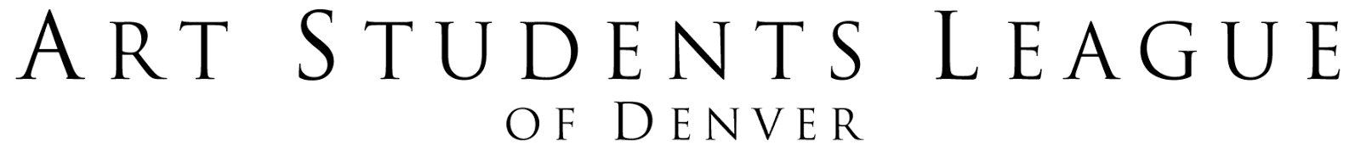

Youth & Teen Studio Scholarships for On-Going Programs (Ages 6 to 17)
Guidelines and Application for 2017

The Art Students League of Denver (ASLD) awards scholarships, when available, to attend our youth on-going programs for ages 6 through 17. The intent of the scholarship program is to provide equal access to education in the visual arts to youth who have a strong desire to learn but lack the financial means to afford our classes. Please review the ASLD catalogs or ASLD website (www.asld.org) for details on current course offerings.

SCHOLARSHIP INFORMATION
Recipients will receive either a Full Scholarship or Partial Scholarship based on eligibility. Scholarships are reviewed and granted on a first-come, first-serve basis until all available funds are used. Recipients and their instructors may be asked to complete an evaluation after completion of the scholarship.

- Full Scholarship: This fee covers tuition for two months of an on-going class OR (1) workshop. A co-pay of
$10 per course is required at time of registration. The scholarship also covers a youth membership for ASLD
valid for one year.
- Partial Scholarship: Recipients receive 50% off of the cost of a course. A partial scholarship covers a youth
membership for ASLD valid for one year.

ELIGIBILITY REQUIREMENTS
Applicants must be Colorado residents. Scholarships are based on financial need (please refer to the tables below). Youth may only apply for one scholarship per year for on-going youth programs. Youth are also eligible to apply separately for a Summer KidaART Camp and Teen Studio Scholarship. We accept applications from multiple youths within the same household. Proof of income (income taxes or recent paystubs) MUST accompany the application form. ASLD will only review complete applications. Incomplete applications will not be accepted. ASLD reserves the right to award scholarships at its own discretion. There is no cash value for scholarships, and we do not offer refunds, transfers or credits for registered courses.

Full Scholarship
Household Income Limits 2017
# in household | Gross Monthly Income
2 | $2,666
3 | $3,000
4 | $3,329
5 | $3,595
6 | $3,862
7 | $4,129
8 | $4,395
Each additional person | Add for each: $266
Partial Scholarship
Household Income Limits 2017
# in household | Gross Monthly Income
2 | $4,262
3 | $4,795
4 | $5,325
5 | $5,794
6 | $6,170
7 | $6,604
8 | $7,029
Each additional person | Add for each: $425

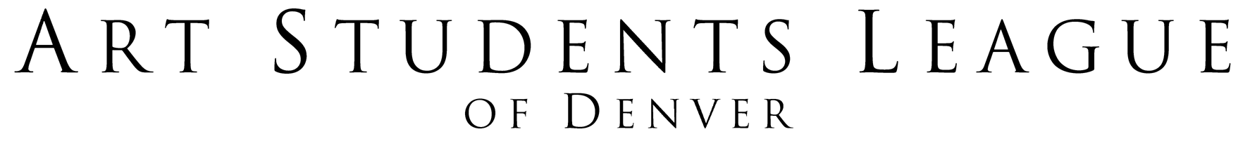

Youth & Teen Studio Scholarships for On-Going Programs (Ages 6 to 17)
Application for 2017

CHILD’S NAME: _________________________________________________________________________________________
PARENT/GUARDIAN NAME: _______________________________________________________________________________
ADDRESS: _______________________________________________________________________________________________
CITY: __________________________________________ ZIP: ________________ COUNTY: ________________________
PHONE: _______________________ CELL PHONE: ______________________
EMAIL: ______________________________________________________

What is your gross monthly household income (before taxes are taken out)? ______________________________

How many family members are part of your household? ____________________

Do you qualify for any government subsidized programs (free lunch, TANF, Medicaid, SNAP, etc.)? Yes No
If yes, please indicate which subsidies you receive:
_______________________________________________________________________________________________________
_______________________________________________________________________________________________________

Why do you want to take a course at the Art Students League of Denver?
_____________________________________________________________________________________________________________________________________________________________________________________________________________________________________________________________________________________________________________________________________________________________________________________________________________________________________________________________________________________________________

In order to receive grant awards from many of the foundations which fund our scholarship program, it is required that we track the ethnicity of our scholarship students. Thank you for indicating your ethnicity or cultural background:

[ ] Caucasian [ ] African American [ ] Asian/Pacific Islander [ ] Hispanic/Latino [ ] Native American
[ ] Other Please specify: ____________________________________________________________

Youth & Teen Studio Scholarships for On-Going Programs (Ages 6 to 17)
Registration Information for 2017

CHILD’S NAME: ____________________________________________________________________________________________
CHILD’S AGE: ____________________ DATE OF BIRTH (MONTH): ____________ (YEAR): ________________

ALTERNATE CONTACT’S NAME: _____________________________________________________________________________
ALTERNATE CONTACT’S CELL or BEST NUMBER: _______________________________________________________________
ALTERNATE CONTACT’S RELATIONSHIP TO CHILD: ____________________________________________________________
PHYSICIAN NAME: ________________________________________ PHYSICIAN PHONE: ____________________________
PHYSICIAN’S HOSPITAL/OFFICE NAME: ______________________________________________________________________
Does your child require special accommodations in order to participate? The Art Students League will do everything possible to accommodate your needs. [ ] yes [ ] no
If yes- please explain: __________________________________________________________________________________________________________________________________________________________________________________________________

What course(s) at ASLD is your student interested in taking?
_________________________________________________________________________________________________
___________________________________________________________________________________________________________________________________________________________________________________________________________________________________________________________________________________________________

Applications may be submitted via email to a.ryan@asld.org, via post, or in person. Proof of income must be submitted with your scholarship application. ASLD will not accept incomplete applications. Scholarship applications are reviewed on a first-come, first-serve basis. Please feel free to contact ASLD with any questions at 303.778.6990 x0, or via email at a.ryan@asld.org.

Thank you for inquiring about the scholarship program at the Art Students League of Denver.
By signing this application you acknowledge all the information provided is accurate and you understand the Scholarship Policy stated above.

Parent/Guardian Signature: _________________________________________________Date: ____________________

Submit applications to:
Art Students League of Denver
Attn: Youth/Teen Studio Scholarships
200 Grant Street
Denver, CO 80203

